### **Capturing data packets on Wireshark**

When you open Wireshark, you see a screen showing you a list of all the network connections you can monitor. You also have a capture filter field to only capture the network traffic you want to see.

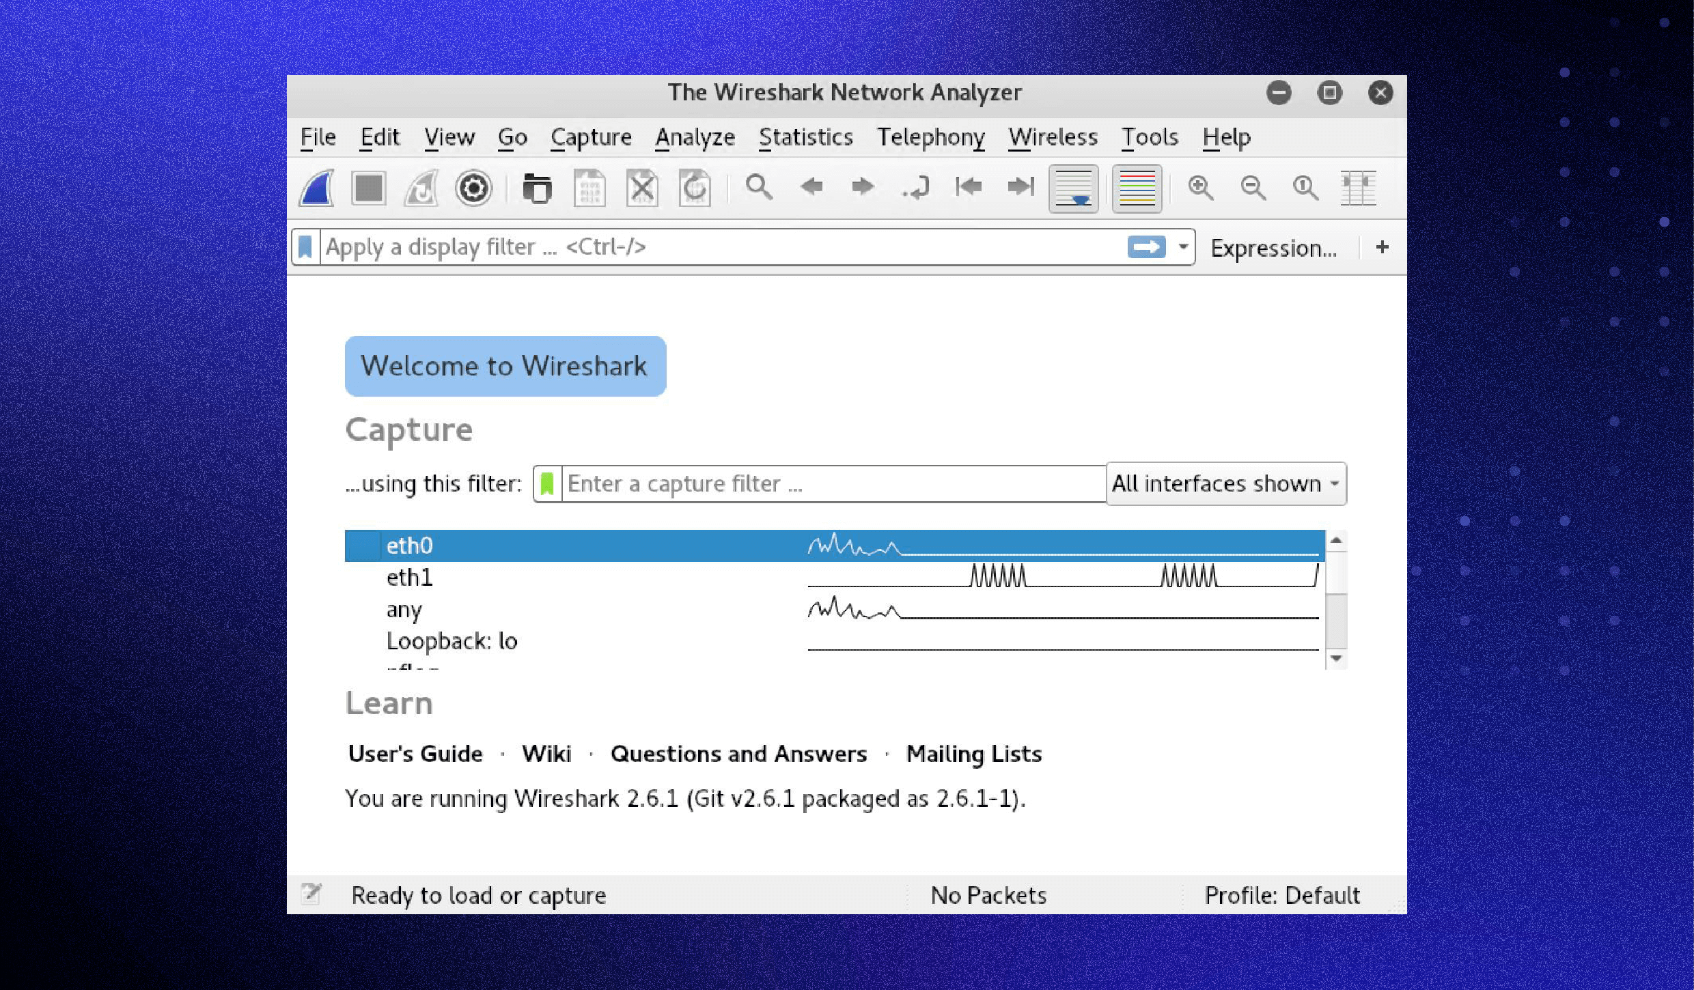

You can select one or more of the network interfaces using shift+left-click. Once select the network interface, you can start the capture, and there are several ways to do that.

**Click the first button on the toolbar, titled “Start capturing packets.”**

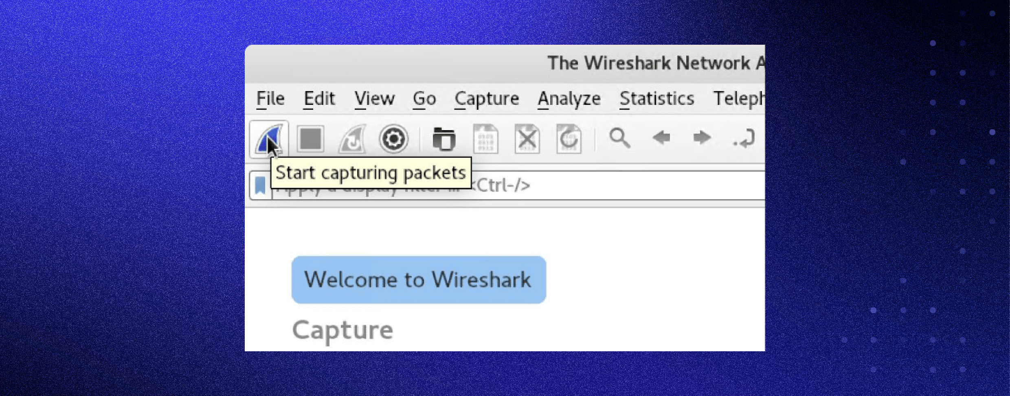

**You can select the menu item Capture -> Start.**

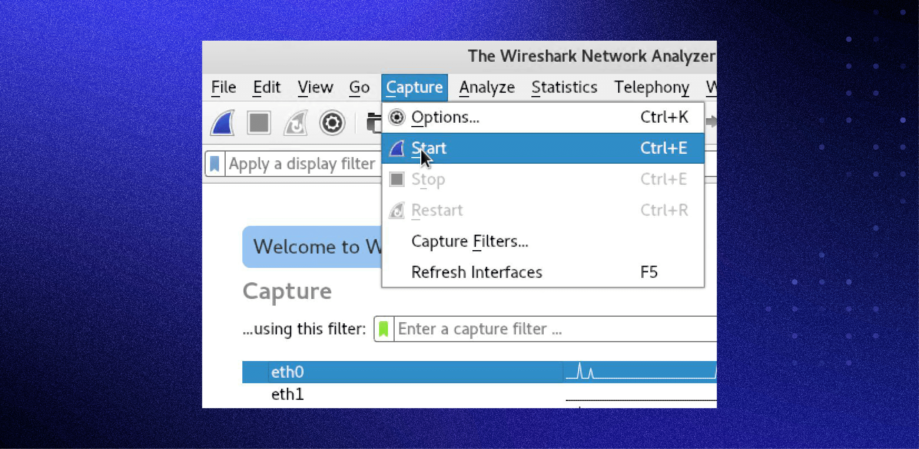

**Or you could use the keystroke Control+E.**

**During the capture, Wireshark will show you the packets captured in real-time.**

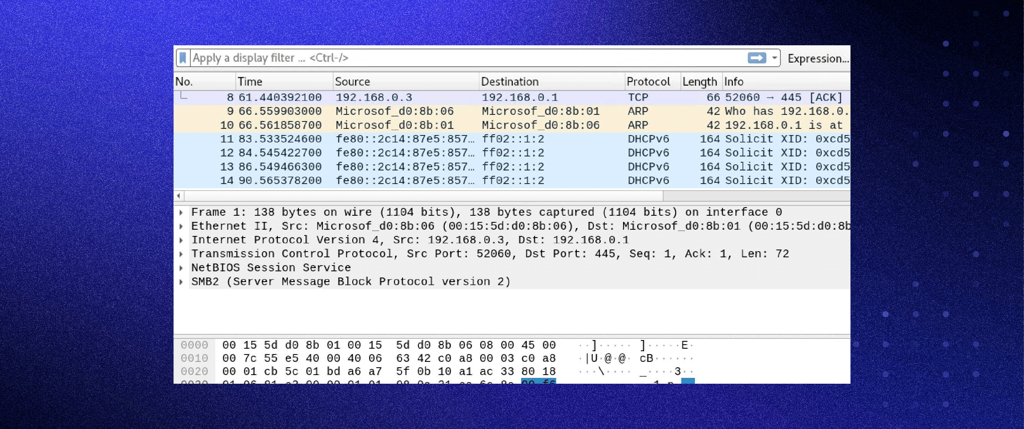

Once you have captured all the packets needed, use the same buttons or menu options to stop the capture as you did to begin.

Best practice dictates stopping Wireshark’s packet capture before analysis.